Beverage Monitor

Users Guide – Beverage Metrics

2011

# Beverage Monitor User Guide

### Introduction

Beverage Monitor is a software application used by the hospitality industry to manage and assess inventory, track pours and provide report based on these factors. “User” as defined in this document is the typical user of this application: the bar/restaurant owner or the manager of the bar/restaurant or stock room attendant.

Version 1.0

### Document Overview

The following is a User Guide for Beverage Monitor software application.

This guide walks the user through all the functionality of this software.

A glossary is provided at the end of this document.

### Application Overview

Beverage Monitor is a software tool that will track and manage bar inventory at the pour level and provide reports for bar/restaurant owners

### Login Screen

* Enter User ID/Password
* Click Login

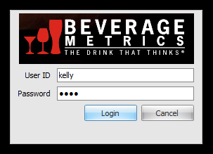

### Dashboard

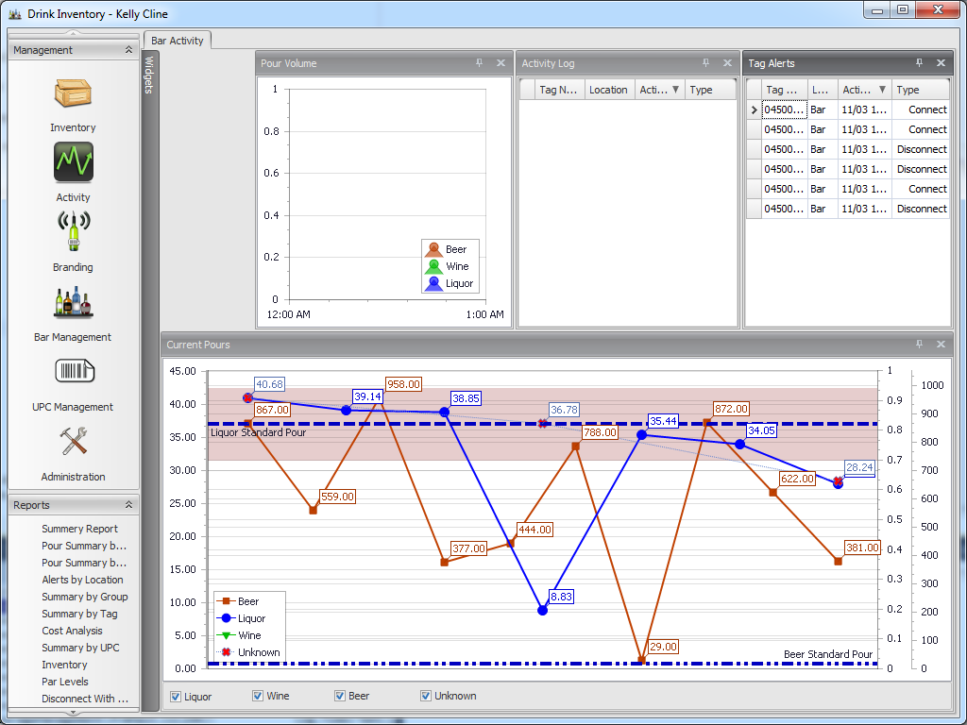

Double Arrows

Left pane for Management activities & Reports.

The dashboard is where all of the software’s functionality can be accessed. The user can choose from the left pane which contains the Management and Reportwindows. These windows can be expanded to reveal their contents. Click the double arrows to collapse and expand the options.

As options are selected from the left pane, a tab appears across the top of the dashboard. Once opened, these tabs can be selected from across the top as the user toggles between activities.

### Inventory

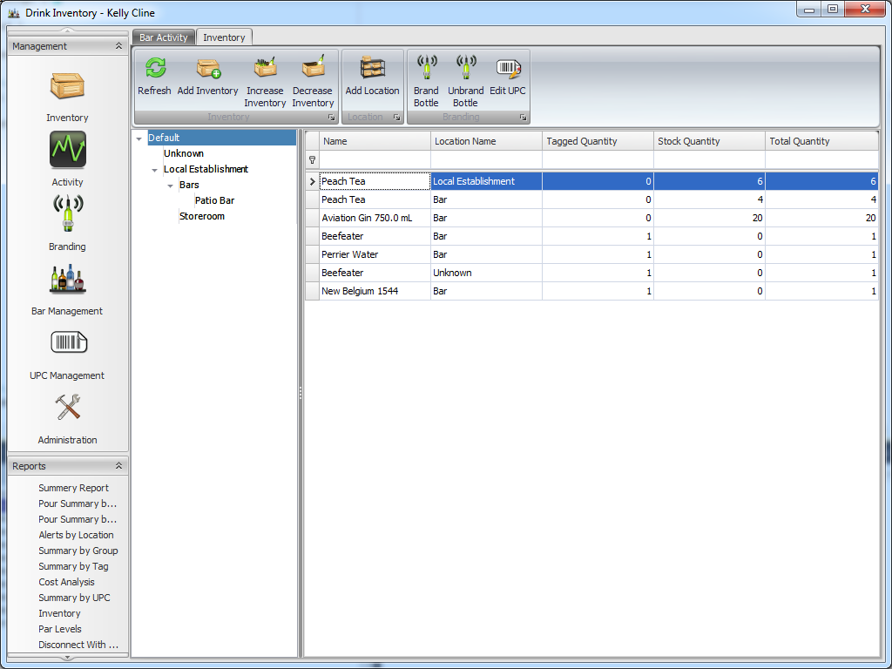

The Inventory tab is where the inventory can be added, removed and reviewed. The major functions of the application can be accessed from this page. Inventory levels can be added and adjusted or moved, locations can be added and updated, and Bottles can be branded and unbranded.

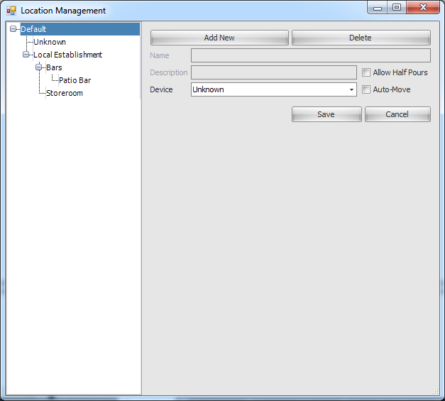

New locations (i.e. bar, store room) can be enter under “Add location” as needed for storage of inventory as necessary to your daily operations.

### Brand a Bottle (Inventory tab)

### 

* Click Branding
* Choose Location from dropdown menu
* If not using a scanner, select “Allow Keyboard Entry”.
* Select type of Inventory: New or Existing
* If not the default, select spout type and dimensions.
* If the bottle is partially used, choose the percent remaining by clicking on the bottle contents. This will display the percent remaining in the bottle.
* Scan/Enter the bottles UPC
* Scan/Enter the tag that will be associated with the bottle.
* Affix RFID Tag associated with the bottle. ***Ensure the “branded” tag is attached to the correct bottle.***

Once the tags have been associated with the bottles, the user can adjust the levels of the product in the bottle and the nozzle size/type.

### Unbrand a Bottle (Inventory tab)

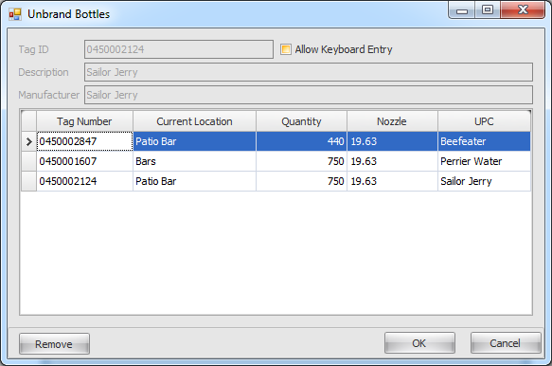

* Select Inventory Tab
* Select Unbrand Bottle
* Scan or enter Tag ID, Description, Manufacturer information
* Select OK

**Note: selecting Remove button only removes that bottle from being Unbranded, it does not “unbrand” the bottle or remove it from Inventory.**

When is a Bottle Unbranded?

### Steps to Add Inventory

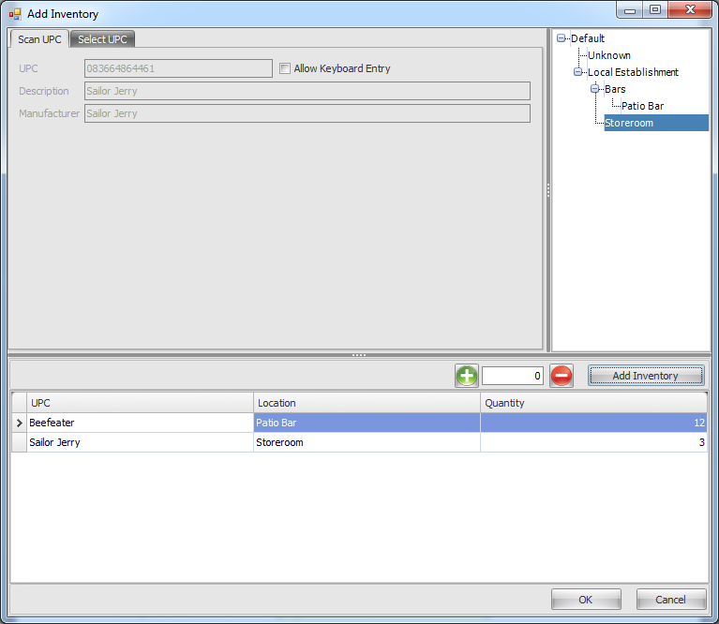

* Click Add Inventory
* If scanner is used, Scan UPC code. If scanner is not used, manually enter information.
* Select location of inventory (bar, store room)
* Enter the quantity
* Click “Add Inventory”

These steps can be repeated until all inventory had been entered. Clicking “OK” will add the items to the inventory.

### Location Management

### 

Locations can be added, edited, and deleted

* To add a new location
  + Select the tree node that should contain the new node.
  + Press the Add New button
  + Enter the Name and description.
  + If the location allows half pours, check the half pour check box
  + If the location should set the tags location based on a reader, select the correct reader from the dropdown and check the auto move check box.
  + Press Save.
* To edit a location
  + Select the tree node to edit
  + Modify the desired attributes
  + Press Save
* To delete a location
  + Select the desired location
  + Press Delete

### Branding

# 

* Click Branding
* Choose Location from dropdown menu
* If not using a scanner, select “Allow Keyboard Entry”.
* Select type of Inventory: New or Existing
* If not the default, select spout type and dimensions.
* If the bottle is partially used, choose the percent remaining by clicking on the bottle contents. This will display the percent remaining in the bottle.
* Scan/Enter the bottles UPC
* Scan/Enter the tag that will be associated with the bottle.
* Affix RFID Tag associated with the bottle. ***Ensure the “branded” tag is attached to the correct bottle.***

Once the tags have been associated with the bottles, the user can adjust the levels of the product in the bottle and the nozzle size/type if needed.

### Bar Management

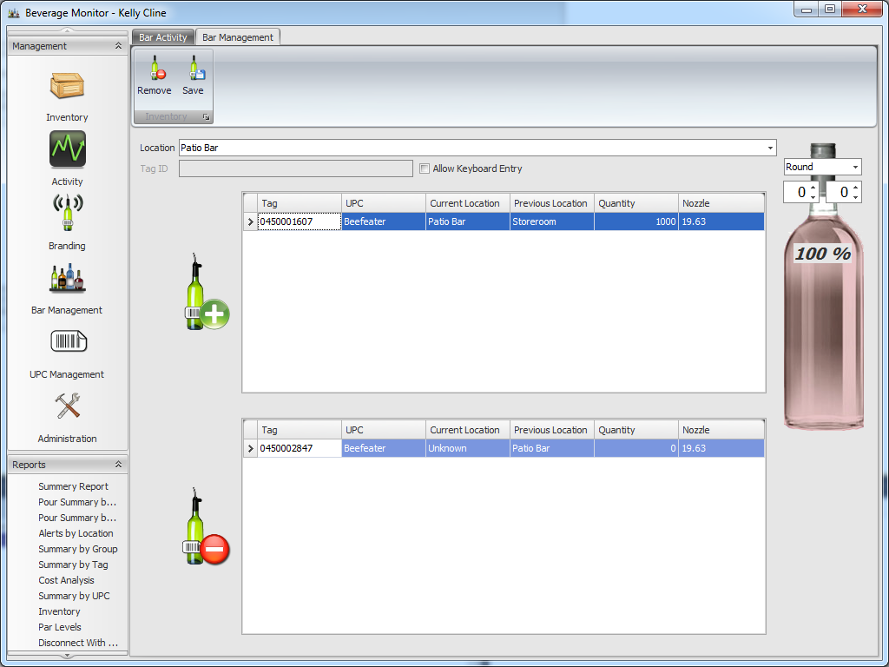

* Choose location
* Scan Tag

### Administration

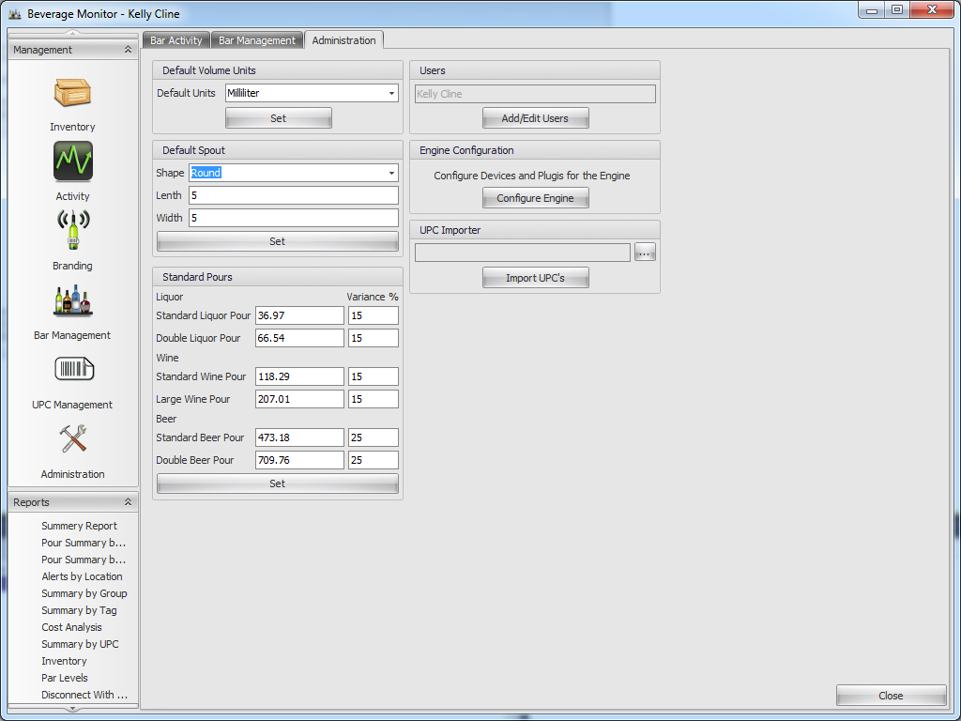

* Enter Default Volume Units – ounces or milliliters.
* Click Set
* Enter Default Spout
* Click Set
* Enter Standard Pours and Variance percentages
* Click Set
* Close close to close the Administration tab

### Decrease/Increase Inventory

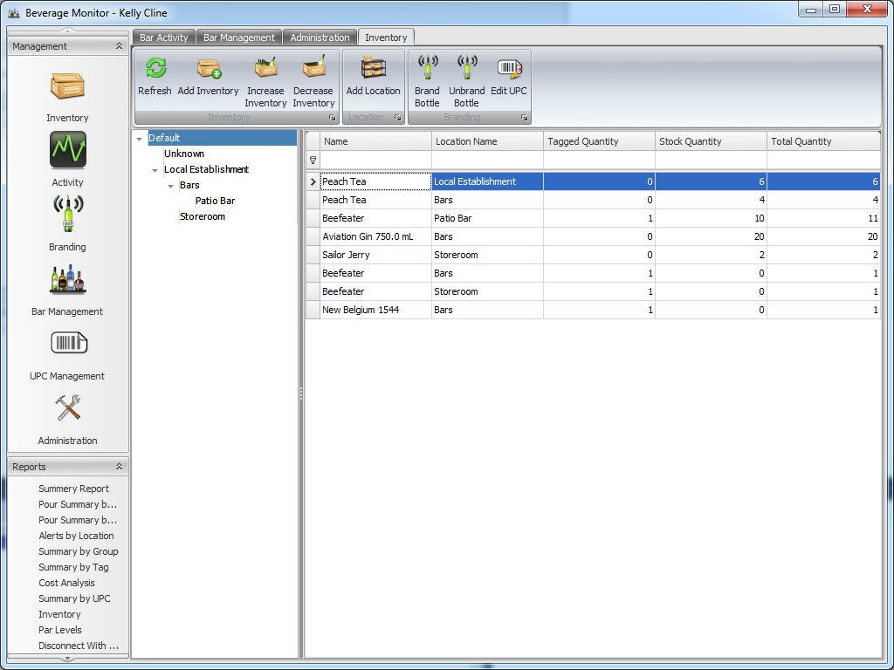

* To Decrease Inventory click “decrease inventory” until the correct value is displayed.
* To Increase Inventory click “increase inventory” until the correct value is displayed.

### Activity

### 

* Choose Activity along left window pane
* Bar activity will be displayed.

### Reports

Summary Report

Pours by UPC

Pours by Tag

Alerts by Location

Summary by Group

Summary by Tag

Cost Analysis

Summary by UPC

Inventory

Par Levels

Disconnect With Volume

Reader List

Pours

Tag List

### UPC Management

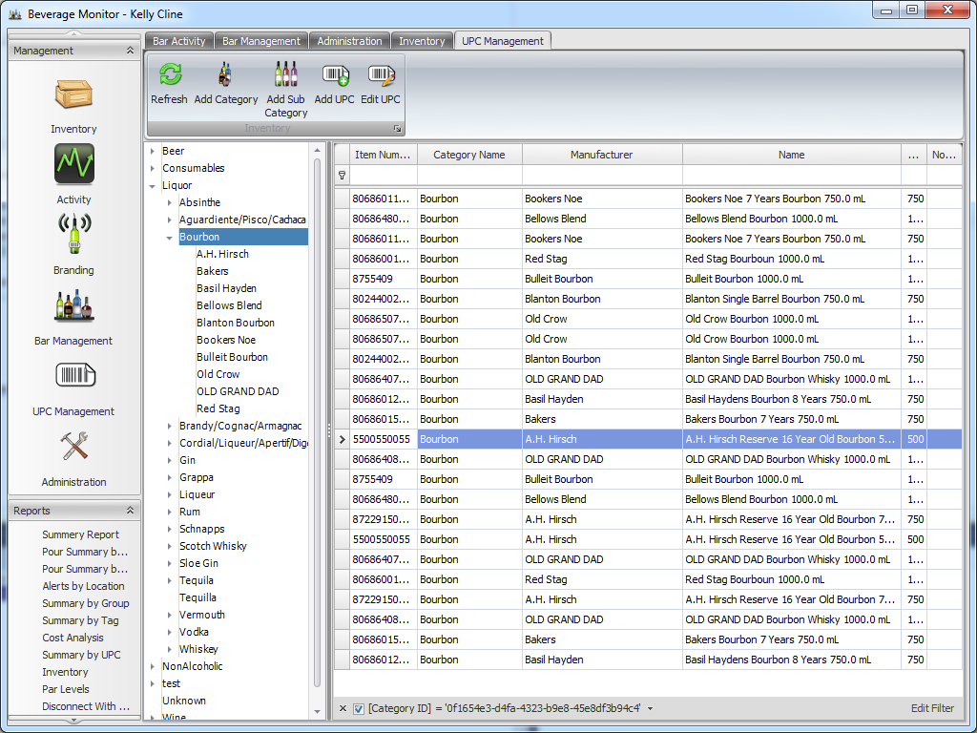

* This is a view of all the UPC’s stored in the system.
* The attributes of these items can be managed from this screen.
* Items can be sorted by clicking on the column headers.
* Items can be filtered by typing in the blank area below the column headers.

### Glossary

Branding – the process by which a bottle is tagged and identified with a specific RFID tag.

Unbranding – the process by which a bottle is disassociated with a specific RFID tag.

Inventory – the units that are sold and reported on via Beverage Monitor software

RFID – Radio Frequency ID is the technology used in the scanner to provide information electronically.

Scanner – barcode reader used to scan UPC codes and tags

User – the person using Beverage Monitor software